Event Actions for Device Unreachable

Please refer this documents for configuring event actions for device unreachable

# General checks before event actions configuration

In E-Mail Event Notification Setup dialog box kindly enable the event notification and make sure test E-mail is working

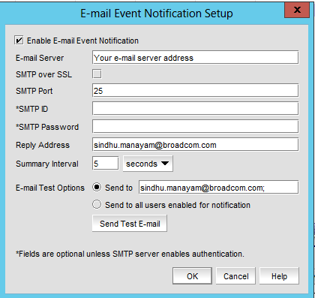

Make sure email notification enabled and user provide valid email address in user profile dialog box

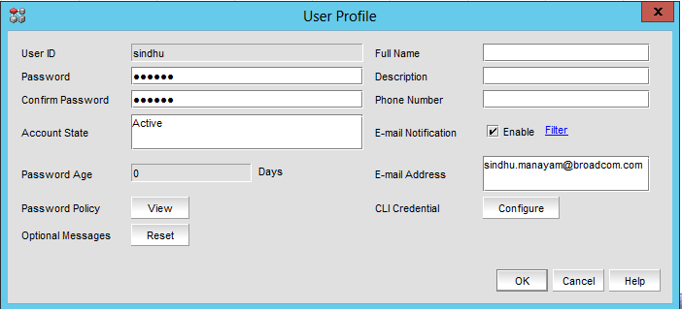

Check the server IP address added in Product Trap Recipients for the switch

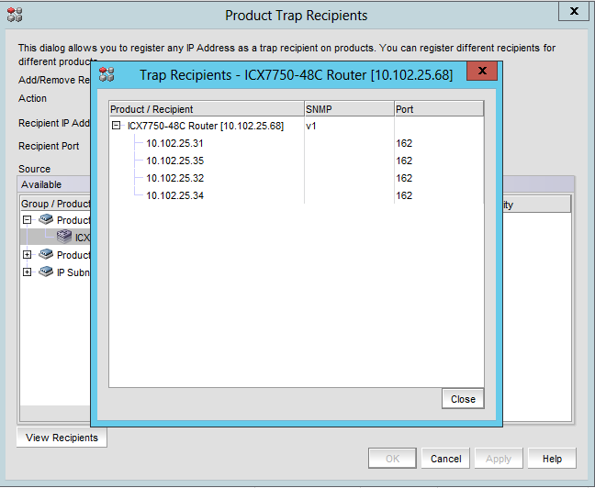

Create Event Actions for Device status changed

Goto Monitor -> Event Processing -> Event Actions

In Event Action dialog box click Add button and follow the below steps

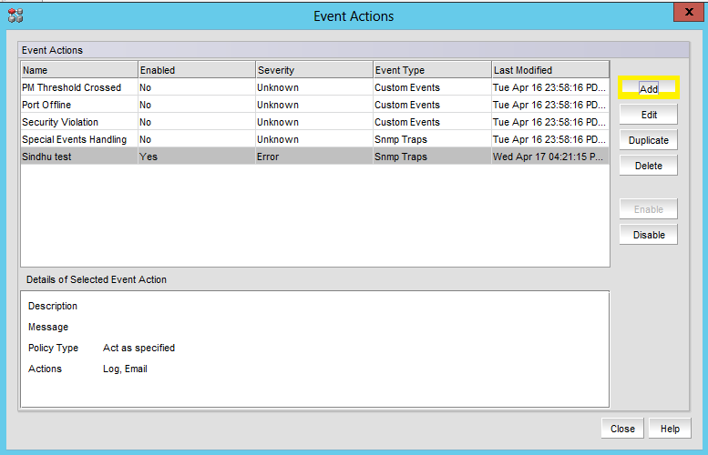

## Step 1: Identification

Provide name, description and select enable check box and click next button for step 2

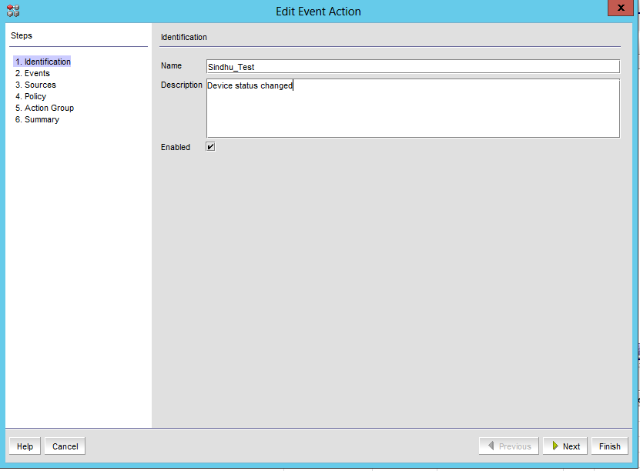

## Step 2: Events

Select Traps, it will show the list of available traps, please expand FastIron / NetIron tree and select the below mention MIB then move it to right side, related to device changes.

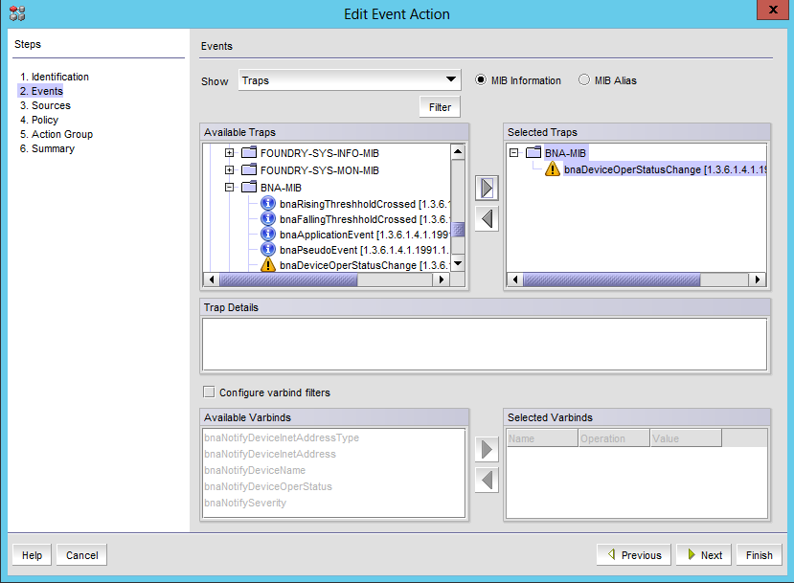

## Step 3: Sources

Select the product in which you need event notification and move it to right side then click next for step 4

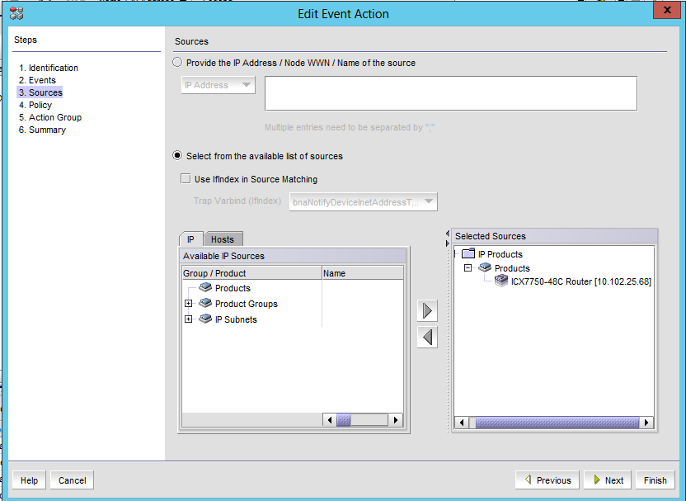

## Step 4: Policy

Enter values in the If occurs __ times within __ fields and select a value from the Minutes list if you want the action to be applied only if the event occurs at a certain frequency

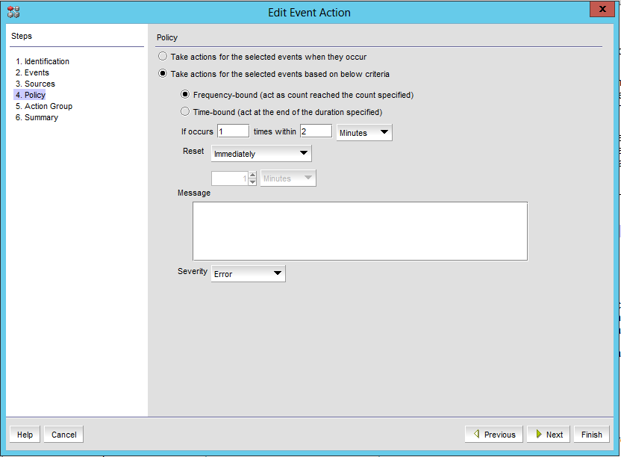

## Step 5: Action Group:

Enable alert by email option and click next

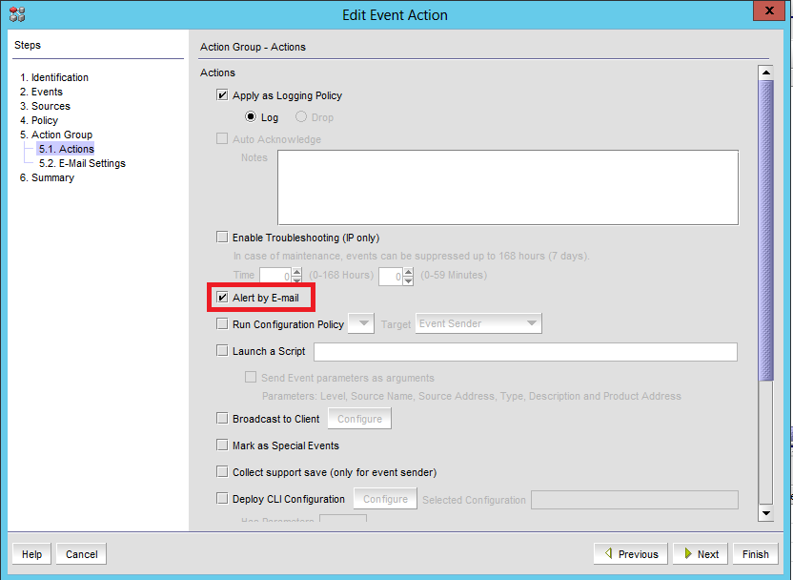

## Step 5.1 E-Mail Settings

Move the recipients to right side and add reply to address if needed

|  |  |
| --- | --- |
| i). | Select the Management application user to whom the e-mail message will be sent from the Available Recipients list, and click the right arrow button to move the recipient to the Selected Recipients list. |

NOTE: Make sure the user you select has an e-mail address defined in a user account.

|  |  |
| --- | --- |
| ii). | (Optional) Add additional e-mail recipient addresses in the Other Recipients field. Separate multiple e-mail addresses with a comma. At least one e-mail address must be specified by either selecting an available recipient from the list (step i) or entering an e-mail recipient.   Step 6: Summary Review your changes and click finish to complete the setup |

Make sure the event which you created is enabled

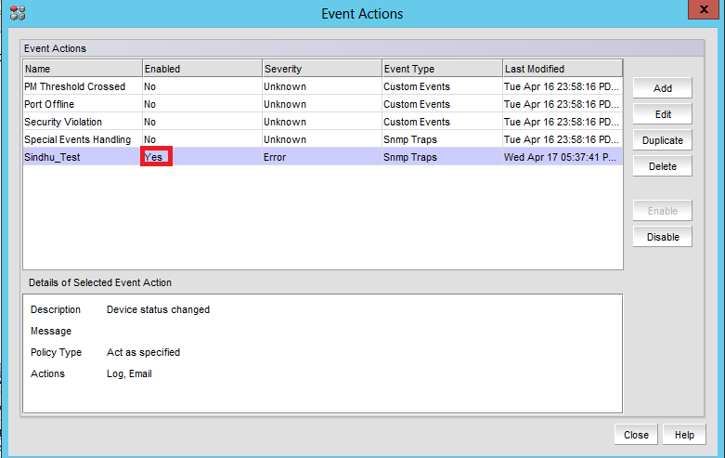

Whenever the device status changes the recipients will get notification by email please refer the below email for your refences.

